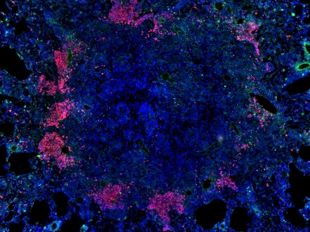
Lung tissue inflammation:

pathogenesis, regulation

and immune response

Preliminary program

May 11, 2016
9 a. m. – registration
Открытие
10:30 | А. Ergeshov, CIT Director | Introductory words
10:40 | Т. K. Kondratieva, Conference Chair | Introductory words
10:45 | Dennis Falzon, WHO | The End TB  Strategy of the World Health Organization
11:00 | Ergeshov A. | Research at the Central Institute for Tuberculosis
Session 1. Pulmonary TB – Inflammation and Immune Response
Chairs: Vladislav Gergert, Olga Demikhova
11:00  Keynote lecture | David McMurray, | Role of lung inflammation in a guinea pig  model of pulmonary tuberculosis
11:50 - Coffee break
12:10  Keynote lecture | Sergei Nedospasov | Contrasting activities of TNF in vivo and a new approach to anti-cytokine therapy
13:00 Lunch
14:00 | Alexander Apt | Experimental genetics of tuberculosis infection
14:50 | Vladimir Yeremeev | Type 1 IFN and saposin D modulation of tuberculous lung inflammation
15:40 | Irina Lyadova | Advances and challenges in understanding immune pathogenesis of tuberculosis infection
16:40 Get together party
Session 2. Pulmonary TB – Cell populations and pathogenesis
Chairs: David McMurray, Tatiana Kondratieva
10:00 | Irina Linge | Functional and phenotypic characteristics of B-lymphocytes in the mouse model of TB infection
10:50 | Olivier Neyrolles | An antibody-independent function for B cells in tuberculosis
11:50 - Coffee break
12:10 | Tatiana Kondratieva, Alex Apt | Lung tissue inflammation and its regulation in experimental TB
13:00 | Igor Kramnik | Necrosis in pulmonary TB granulomas: mechanisms and therapeutic approaches
14:00 - Lunch
14:00 | Anca Dorhoi | Myeloid regulatory cells in pulmonary bacterial infections
14:50 | George Kosmiadi | Local lung immune response in TB-affected human lung
18:00 – Speakers Dinner
May 13, 2016
Session 3. Non-tuberculous lung inflammation
Chairs: Alexander Apt, Igor Kramnik
11:00 | Evgeniy Eruslanov | The origin and role of inflammatory APC-like hybrid neutrophils in early-stage human lung cancer
11:50 | Igor Stepanyan | Diffuse interstitial lung inflammatory diseases
12.40-13:00 - Coffee break
13:00 | Evgeniy Shmelev | Sarcoidosis - a puzzle desease.
13:45 | Marina Shevchenko | Interaction of innate immunity cells with Aspergillus fumigatus in respiratory tract
14:50 - Conclusion remarks
15:00 – Lunch and departure

