Koch-Metschnikof Forum on Tuberculosis
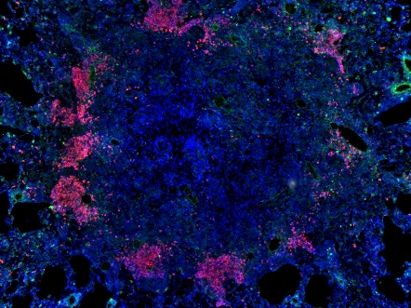
The School
«Lung tissue inflammation:
pathogenesis,
regulation
and immune response»

April, 25, 2017

Registration 9.00 – 10.30
Opening ceremony
10:30 – 10:55 | A. Ergeshov  A. Apt  D. McMurray  Academy official (TBA) | Opening remarks
Session 1 – Mycobacterial infections –immune response and genetic control
Chairs: D. McMurray, O. Demikhova
11:00-11:30 | Erwin Schurr  McGill University | Human genetics of M. tuberculosis infection
11:30-12:00 | Alexander Apt  CIT, Moscow | IL-11 in tuberculosis infection
12.00-12.30 coffee break
12:30-13:00 | Irina Linge  CIT, Moscow | Regulation of M. avium infection in mice
13.00-13.30 | Tatiana Azhikina  Institute for Bioorganic Chemistry, Moscow | Short regulatory mycobacterial RNAs
13:40 – 14.40 Lunch
Session 2. Pulmonary TB – Inflammation and Immune Response
Chairs: A. Apt, V. Gergert
14:45-15:15 | Tobias Dallenga  Borstel, Germany | Inhibition of neutrophil necrosis controls Mycobacterium tuberculosis growth after removal by macrophages
15:15-15:45 | Irina Lyadova  CIT, Moscow | Th1 and Th17 responses in active and latent TB
15:45-16:15 | David McMurray  A&M University of Texas | Opposing roles of TNF-a in a  guinea pig model of pulmonary TB
16:15- 16:45 | Vladimir Yeremeev  CIT, Moscow | Short regulatory RNAs in the lung tissue of TB patients
17.00 Get together party
April 26, 2017
Session 3. Mycobacterial variability
Chairs: T. Ulrichs, T. Kondratieva
10:30-11:00 | Matthias  Merker,  Borstel, Germany | Evolution and recent spread of multidrug resistant Mycobacterium tuberculosis strains in Eastern Europe
11:00-11:30 | Larisa Chernousova  CIT, Moscow | Phonotypic sensitivity to anti-TB drugs in M. tuberculosis strains carrying mutations in genes involved in RIF and IHN resistance
11:30 – 11:45 Coffee break
11:45-12:15 | Arseny Kaprelyants  Bach Institute, Moscow | Mycobacterial dormancy-reactivation
12:15 – 12:45 | Vera Ustinova  CIT, Moscow | Detection of non-TB mycobacteria in Russia
13:00-14:00 - Lunch
Session 4. New drugs and protective factors
Cairs: S. Stengler, V. Yeremeev
14:00-14:30 | Boris Nikonenko  CIT, Moscow | Activity of new indole derivates against Mycobacterium tuberculosis and Mycobacterium avium
14:30-15:00 | Vadim Makarov  Bach Institute, Moscow | Actual progress with PBTZ169 development
15:00-15:30 | Stefan Stengler  University of Ulm, Germany | Lipoarabidomanna-responsive polycytotoxic T cells are associated with protection in human tuberculosis
15:30-16:00 | Olivier Neyrolles  Research Center, Toulouse, France | TBA
17:15 – Speakers Dinner
April 27, 2017
Session 5. School on lung inflammation
Chairs: Alexander Apt, Tatiana Kondratieva
11:00- 12:00 | Prof. Timo Ulrichs  Koch-Metchnikoff Forum, Berlin, Germany | Research in diagnostics, treatment and prevention of tuberculosis: state of the art and challenges in the coming years
12:00-13:00 | David McMurray, A&M University, Texas, USA | The role of neutrophils in a guinea pig model of pulmonary tuberculosis
13:00-13:15 - Coffee break
13:15-14:15 | George Kosmiadi  CIT, Moscow | Lung immunity in TB and non-infectious deseases
14:15 -15:15 Conclusion remarks, Posters discussion
15:30 – Lunch and departure

